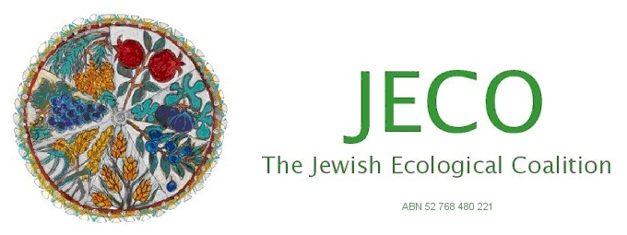
Application for Affiliate Membership of the
Jewish Ecological Coalition Inc (JECO)

Full name of organisation ___________________________________________________________

Postal address ____________________________________________________________________
wish to become an affiliate member of The Jewish Ecological Coalition Inc. (JECO).
By submitting this membership form, the organisation listed above agrees to support JECO’s aims and objectives as identified on the JECO website www.jeco.org.au .
The organisation also agrees to appoint a delegate to the JECO Committee.

Appointed delegate _______________________________________________________________

Delegate’s phone number __________________________________________________________

Delegate’s email _______________________________________________________ __________

Position held in organisation ________________________________________________________

Signature ___________________________________________________ Date_________________

Specify position of signatory in organisation ____________________________________________
Contact details for notices of meetings and other correspondence (email address preferred):

Email ___________________________________________________________________________

Postal address ____________________________________________________________________

Please print this application form and post it to JECO c/- Stand Up, 128A Wattletree Road, Malvern 3144 or email it to info@jeco.org.au .
Payment of the yearly affiliate membership of $100 can be made by cheque payable to JECO and sent to the above address or by direct deposit to the Bendigo Bank, BSB 633 108, Account 124 223 595.

